SET 27: PATIENT HEALTH RISK ANALYSIS USING R
AIM
To analyze patient health indicators such as age, BMI, blood pressure, and cholesterol using statistical plots and visualizations in R.
DATASET
Patient ID | Age | BMI | BP | Cholesterol
P1 | 25 | 22 | 120 | 180
P2 | 40 | 28 | 135 | 210
P3 | 55 | 30 | 145 | 240
P4 | 35 | 26 | 130 | 200
P5 | 60 | 32 | 150 | 260
QUESTION 1: SCATTERPLOT MATRIX AND CORRELATION
Aim: To examine relationships among age, BMI, blood pressure, and cholesterol.
Program:
age<-c(25,40,55,35,60)
bmi<-c(22,28,30,26,32)
bp<-c(120,135,145,130,150)
chol<-c(180,210,240,200,260)
health<-data.frame(age,bmi,bp,chol)
pairs(health,col="blue",pch=19)
print(cor(health))
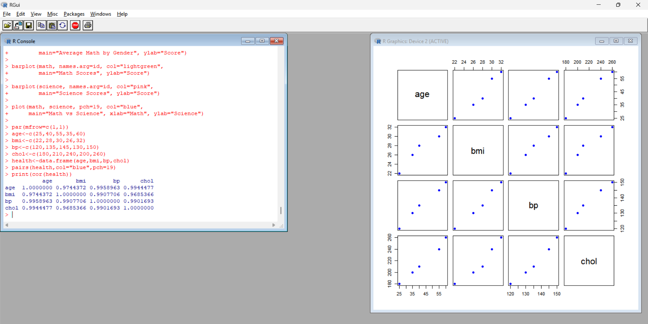
Procedure:
- Enter the patient health data.
- Combine the numerical variables into a data frame.
- Create a scatterplot matrix using pairs().
- Calculate the correlation matrix using cor().
Output: A scatterplot matrix and correlation matrix of the four health indicators.
Observation: The variables generally show positive relationships in this dataset.
QUESTION 2: Q-Q PLOT AND ECDF
Aim: To examine the distribution of cholesterol values using a normal Q-Q plot and an empirical cumulative distribution function (ECDF).
Program:
chol<-c(180,210,240,200,260)
par(mfrow=c(1,2))
qqnorm(chol,col="blue",main="Q-Q Plot")
qqline(chol,col="red")
plot(ecdf(chol),main="Cholesterol ECDF",
xlab="Cholesterol",ylab="Cumulative Probability",
verticals=TRUE,col="blue")
par(mfrow=c(1,1))
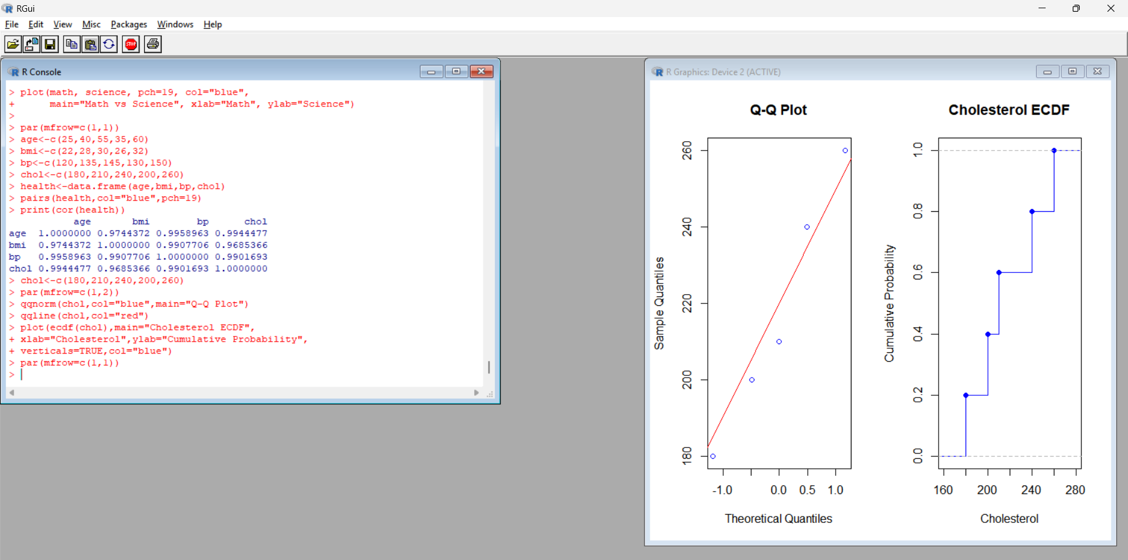
Procedure:
- Enter the cholesterol values.
- Create a normal Q-Q plot using qqnorm().
- Add a reference line using qqline().
- Create an ECDF plot using ecdf().
Output: A Q-Q plot and an ECDF plot of cholesterol values.
Observation: The Q-Q plot compares the observed values with a theoretical normal distribution. The ECDF displays cumulative probabilities. Five observations are insufficient to assess normality reliably.
QUESTION 3: BAR CHART OF AVERAGE HEALTH INDICATORS
Aim: To calculate and visualize the average values of age, BMI, blood pressure, and cholesterol.
Program:
age<-c(25,40,55,35,60)
bmi<-c(22,28,30,26,32)
bp<-c(120,135,145,130,150)
chol<-c(180,210,240,200,260)
avg<-c(mean(age),mean(bmi),mean(bp),mean(chol))
print(avg)
barplot(avg,names.arg=c("Age","BMI","BP","Cholesterol"),
col=c("skyblue","orange","green","pink"),
main="Average Health Indicators",ylab="Average Value")
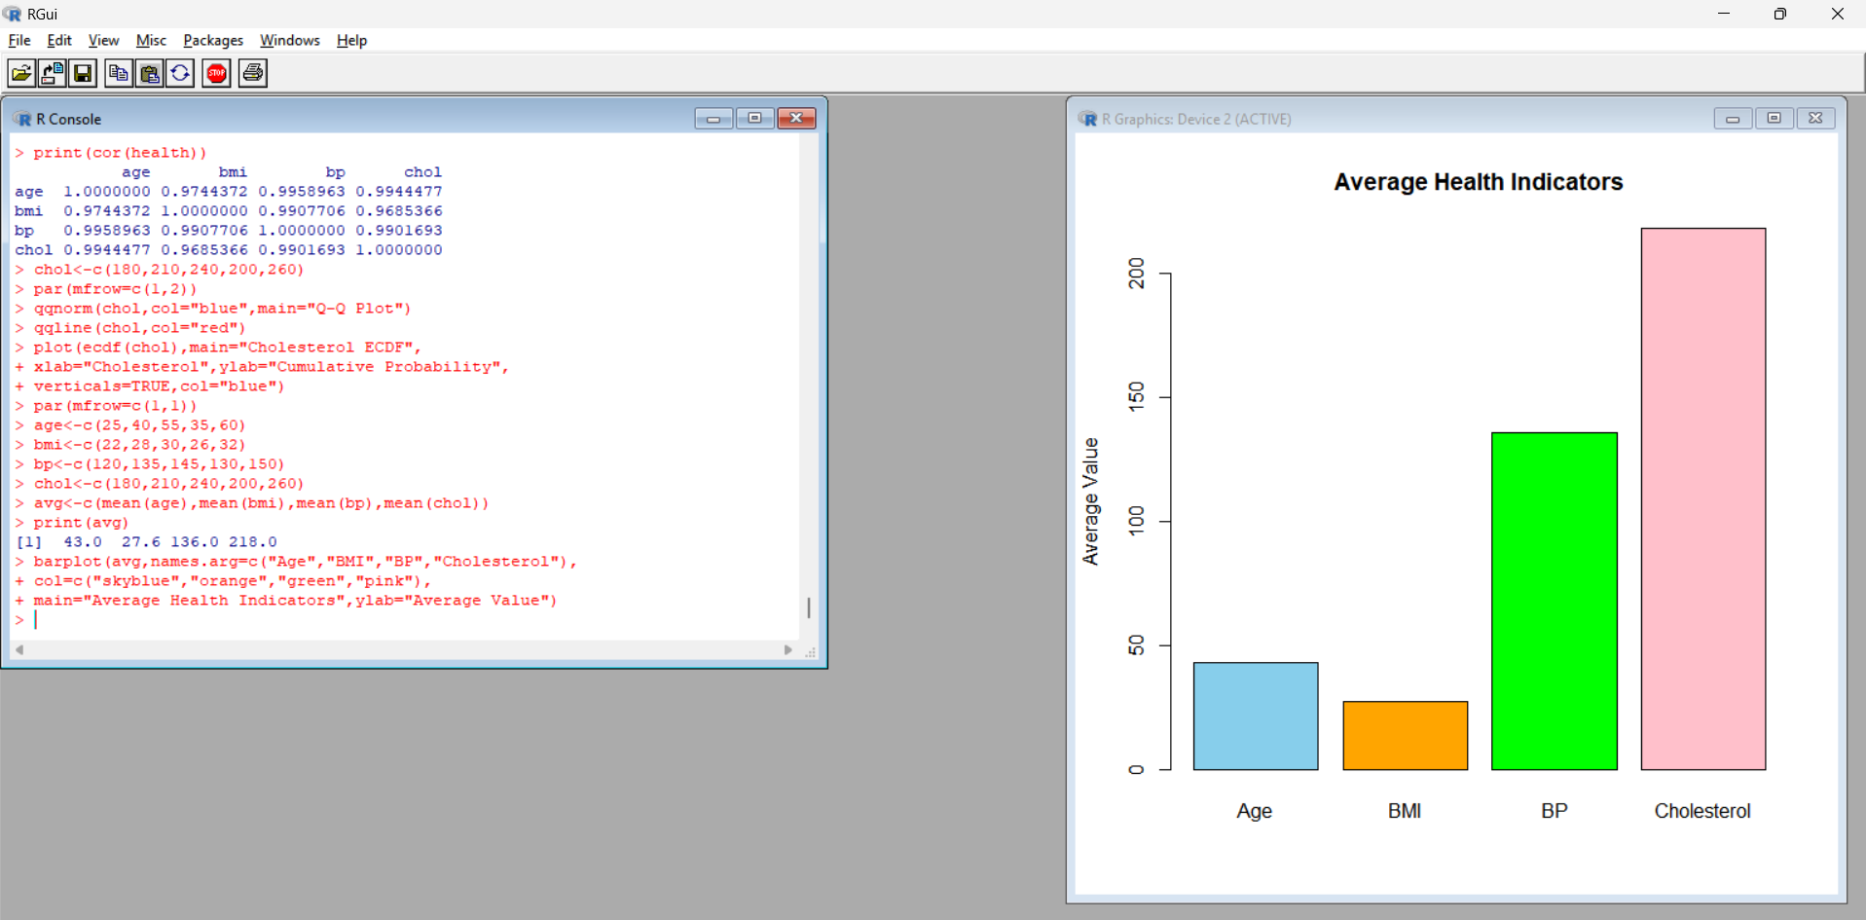
Procedure:
- Enter the four health indicators.
- Calculate their averages using mean().
- Store the averages in a vector.
- Create a bar chart using barplot().
Output: A bar chart showing the average health indicators.
Observation:
Health Indicator | Average
Age | 43
BMI | 27.6
Blood Pressure | 136
Cholesterol | 218
The indicators use different units and scales, so their bar heights should not be compared directly as measures of health risk.
QUESTION 4: PATIENT HEALTH DASHBOARD
Aim: To create a dashboard for visualizing patient health indicators using multiple plots in R.
Program:
id<-c("P1","P2","P3","P4","P5")
age<-c(25,40,55,35,60)
bmi<-c(22,28,30,26,32)
bp<-c(120,135,145,130,150)
chol<-c(180,210,240,200,260)
par(mfrow=c(2,2))
barplot(bmi,names.arg=id,col="skyblue",main="BMI by Patient")
barplot(bp,names.arg=id,col="orange",main="Blood Pressure")
plot(age,chol,pch=19,col="red",main="Age vs Cholesterol",
xlab="Age",ylab="Cholesterol")
plot.new()
text(0.5,0.8,"PATIENT HEALTH SUMMARY",font=2)
text(0.5,0.6,paste("Highest BMI:",max(bmi)))
text(0.5,0.4,paste("Highest BP:",max(bp)))
text(0.5,0.2,paste("Highest Cholesterol:",max(chol)))
par(mfrow=c(1,1))
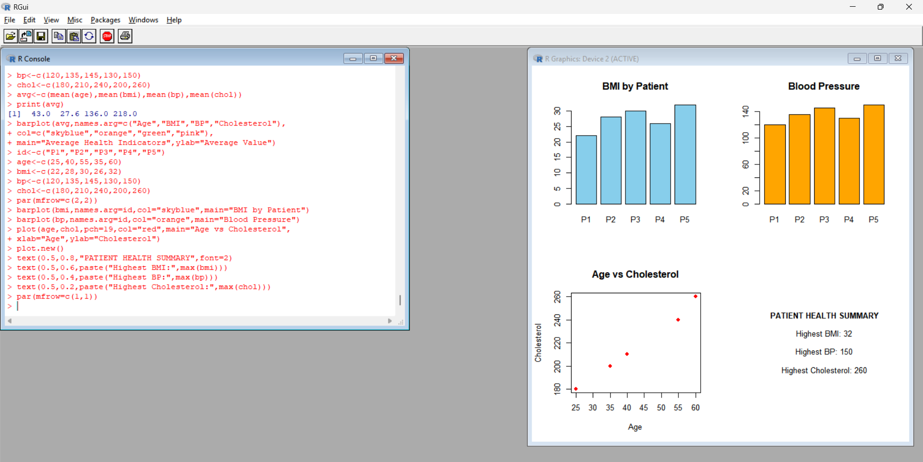
Procedure:
- Create a bar chart of BMI by patient.
- Create a bar chart of blood pressure by patient.
- Plot age against cholesterol.
- Display the maximum values in a summary panel.
- Arrange the plots using par(mfrow=c(2,2)).
Output: A dashboard displaying BMI, blood pressure, age versus cholesterol, and a patient summary.
Observation: Patient P5 has the highest BMI (32), blood pressure (150), and cholesterol (260) in the dataset. These values alone do not establish a medical diagnosis.
RESULT
Patient health data were analyzed using a scatterplot matrix, correlation matrix, Q-Q plot, ECDF, bar chart, and dashboard in R. Patient P5 recorded the highest BMI, blood pressure, and cholesterol values. The findings should be interpreted cautiously because the dataset contains only five patients.

